INTRODUCTION TO RDBMS MINI PROJECT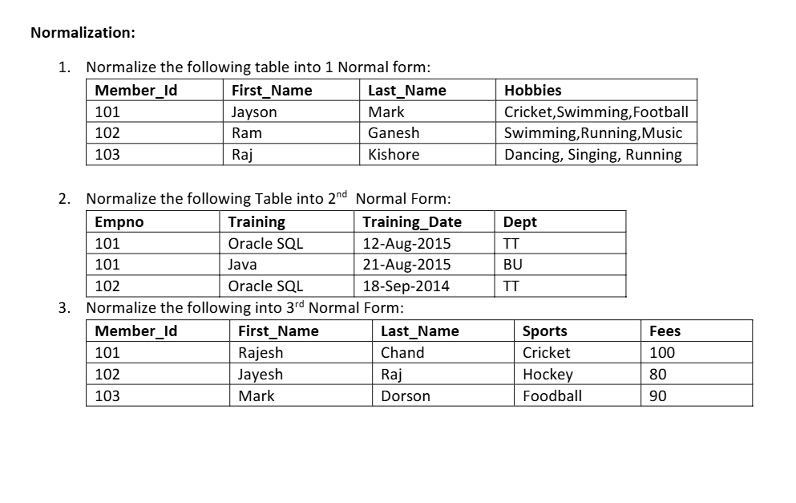
Name: Database Normalization
Objective
To normalize the given database tables into 1NF, 2NF, and 3NF to reduce redundancy and improve data consistency.

- Normalize the following table into 1NF
Problem
The Hobbies attribute contains multiple values in a single column.
This violates the rule of First Normal Form, which states that every column should contain only one atomic (single) value.

Steps Performed
- Identified the multi-valued attribute Hobbies.
- Split each hobby into a separate row.
- Repeated the remaining member details for every hobby.

Normalised Table:
Member_Id | First_Name | Last_Name | Hobby
101 | Jayson | Mark | Cricket
101 | Jayson | Mark | Swimming
101 | Jayson | Mark | Football
102 | Ram | Ganesh | Swimming
102 | Ram | Ganesh | Running
102 | Ram | Ganesh | Music
103 | Raj | Kishore | Dancing
103 | Raj | Kishore | Singing
103 | Raj | Kishore | Running

Result
The table now satisfies First Normal Form (1NF) because each column contains only a single value and there are no repeating groups.

- Normalize the following table into 2NF
Primary Key
Composite Key = (Empno, Training)

Functional Dependencies
(Empno, Training) → Training_Date
Empno → Dept
Since Dept depends only on Empno and not on the complete composite key, this is called a Partial Dependency.
Partial dependency violates Second Normal Form (2NF).

Steps Performed
- Identified the composite primary key.
- Found that Dept depends only on Empno.
- Removed the partial dependency.
- Created two separate tables.

Employee Table
Empno | Dept
101 | TT
102 | TT

Training Table
Empno | Training | Training_Date
101 | Oracle SQL | 12-Aug-2015
101 | Java | 21-Aug-2015
102 | Oracle SQL | 18-Sep-2014

Result
The partial dependency has been removed. Every non-key attribute is fully dependent on the primary key. Hence, the tables satisfy Second Normal Form (2NF).

- Normalize the following table into 3NF

Functional Dependencies
Member_Id → First_Name
Member_Id → Last_Name
Member_Id → Sports
Sports → Fees

Here,
Member_Id → Sports → Fees
This is called a Transitive Dependency.
A transitive dependency violates Third Normal Form (3NF).

Steps Performed
- Identified that Fees depends on Sports, not directly on Member_Id.
- Removed the transitive dependency.
- Created two separate tables.
Member Table
Member_Id | First_Name | Last_Name | Sports
101 | Rajesh | Chand | Cricket
102 | Jayesh | Raj | Hockey
103 | Mark | Dorson | Football

Sports Table
Sports | Fees
Cricket | 100
Hockey | 80
Football | 90

Result
The transitive dependency has been removed. Every non-key attribute now depends only on the primary key, satisfying Third Normal Form (3NF).

